SUBMITTED BY SETHU KANNAN M

# IBM ASSIGNMENT- 2

TEAM ID :

IBM-Project-41004-1660638306

NAME : SETHU KANNAN M ROLL NO: 920319106021

Build a python code. Assume u get temperature and humidity values(generated with random function to a variable) and write a condition to continuously detect alarm in case of high temperature.

# program:

import random temp=random.randint(0,100) humid=random.randint(0,100) print("Note:") print ("Normal Temperature Level is 50°C") print ("Normal Humidity Level is 50%")

print (" ")

if (temp>=50):

print ("Temperature is High",temp,"°C") else:

print ("Temperature is Normal",temp,"°C") if (humid>=50):

print ("Humidity is High",humid,"%") else:

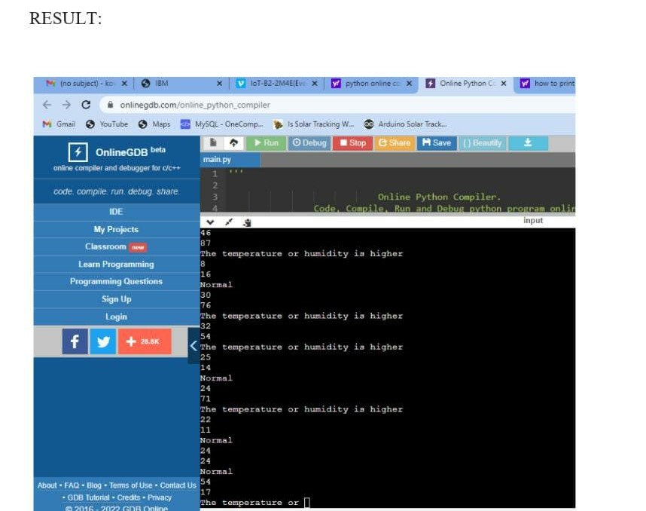print ("Humidity is Normal",humid,"%")